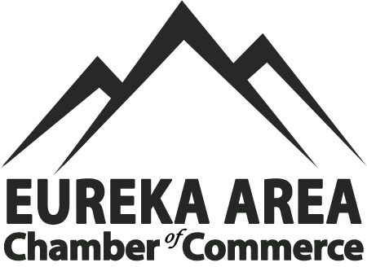

Dear business owner,

The Eureka Area Chamber of Commerce would like to invite you to join our organization.

A stronger local economy starts here! As a growing community we would love to have your partnership with the Eureka Area Chamber of Commerce today. Let’s collaborate to:

- Boost business visibility
- Advocate for local business interests
- Network with fellow entrepreneurs
- Increase tourism

The mission of the Eureka Area Chamber of Commerce is:

“To support its members through business promotions, networking opportunities, educational programs, visitor information services, and community events that reflect our unique Northwest Montana culture.”

We are currently working on some exciting new ways for the community to connect with our members very soon including updates to our website, referral and networking programs, and increased interest in the community through tourism.

With your support we can really make a difference in this business community!

The Chamber is better because of our members! We are stronger together!

Low-cost membership dues are as follows: Non-profit membership yearly dues are $50.00, and $100.00 for profit organizations. Non-profit organizations will need to include a copy of their non-profit status with application. Help us drive business to your doors.

I have included a membership form for your convenience. If you have any questions, please contact us. Our business hours are Tuesday through Thursday from 10AM to 2PM, and our phone number is (406)-297-4636. Email us anytime at eurekachamber01@gmail.com

Eureka Area Chamber of Commerce
P.O. BOX 186
11 Dewey Ave. Eureka, MT, 59917
(406)-297-4636
eurekachamber01@gmail.com

