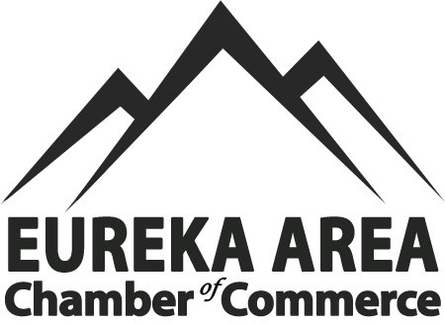

2026 RENDEZVOUS VILLAGE VENDORS INVITATION

The Eureka Area Chamber of Commerce is pleased to invite you to participate in the 47th Annual Rendezvous Days Festival on April 25, 2026 - a time-honored way to celebrate our rich history in the Eureka Area. We are currently accepting applications from vendors interested in joining us on this Fun day!

The Vendor fair is in the Historical Village of Eureka, MT and the Food Court will be in Riverside Park on Saturday April 26th. Various events will also be going on throughout Saturday, including live entertainment, a parade, and so many other noteworthy activities close to the Village area. If you have more questions, please call the Chamber office at 406-297-4636, hours are 9 AM to 3 PM Monday through Friday.

Vendor fair hours are 9:00 am to 5:00 pm on Saturday, April 25, 2026. Because there is no 24-hour security, set-up is on Saturday, April 25th between 7:00 am to 8:30 am. Prior to the event, each vendor will be assigned a 12’x12’ space. As a benefit, members of the chamber can choose their spot (first come, first serve). All others will be assigned and communicated before the event. Spaces will be carefully planned and marked when you arrive on Saturday. Please respect the boundaries of your assigned spot. Once you unload, you will be required to move your vehicle to allow others to unload. All vehicles are to be moved from the Village area by 8:30 am. Due to irrigation, PLEASE DO NOT DRIVE OR USE STAKES ON THE GRASS. Failure to comply could result in a $500 fine and repairs paid by you.
The space fee for vendors will be $45.00 for members, $50.00 – for non-members, for the day (food trucks are $100 per day for members and $125 per day for non-members). For vendor village, electricity is available and will be $10 per plug in. All fees paid in full are required to reserve your space. There will be no refund for cancellations within 14 days of the event. Deadline for vendors to have forms in the office will be April 1 2026, or when all spaces are full, whichever comes first.
This is an outdoor rain, shine or snow event so come prepared for the weather! All vendors are expected to stay for the duration of the fair. Please do not tear down early.

Eureka Area Chamber of Commerce is happy to welcome each vendor to participate in this exciting and profitable event, however we ask that all parties are kind and professional to each other. Please do not display or sell anything offensive or derogatory at this event. In addition, you must follow all rules for sales of food, weapons, etc. Eureka Area Chamber of Commerce has the right to ask anyone to leave the event at any time should it be necessary to maintain the safety and enjoyment of all involved.

Please send completed application and payment (check or money order) to
Eureka Area Chamber of Commerce
Rendezvous Days Village Vendor
PO Box 186, Eureka, MT 59917 or drop it off at the office at 11 Dewey Ave, Eureka

Cresta Nicol
Executive Director
Eureka Area Chamber of Commerce
(406) 297-4636 eurekachamber01@gmail.com

